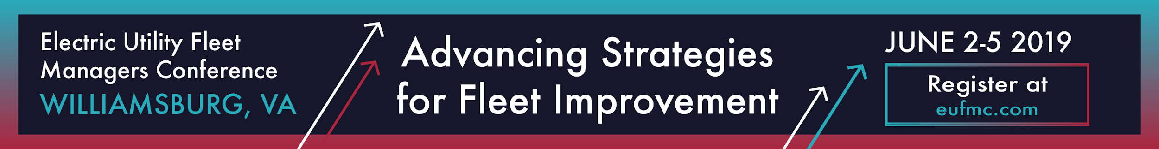

EUFMC Proves its Value

The 66th annual Electric Utility Fleet Managers Conference, held June 2-5, 2019 at the Williamsburg Lodge and Conference Center in Williamsburg, Virginia, brought together representatives from fleets, manufacturers and service providers for a highly valuable educational and networking event.

“Every year, EUFMC serves as an informative forum for fleet managers,” said Chuck Bunting, EUFMC President and Fleet Manager at NiSource. “The conference educational program, equipment exhibits and networking opportunities continue to be important for the industry because EUFMC helps fleets and suppliers address challenges and exchange valuable ideas.”

Attendance at EUFMC in 2019 included 128 utility fleet representatives from nearly 70 investor-owned electric utilities, electric cooperatives and electrical contractors, including about 30 first time attendees. Also at the conference were more than 350 representatives from about 100 manufacturers and service providers.

EUFMC includes Utility Equipment Drive-Through Demonstrations with educational and technical presentations by suppliers, and an Equipment Show with more than 60 displays of vehicles, equipment, components and a wide range of technologies and services.

The EUFMC educational program-- Advancing Strategies For Fleet Improvement – featured presentations by fleet executives, industry experts and suppliers. Leading off the General Session as keynote speaker was Earl C. “Duke” Austin, Jr., president and chief executive officer of Quanta Services.

Quanta, a specialized utility contractor serving electric power, pipeline, industrial and communications customers, operates the sixth largest fleet in North America.

Austin has played a fundamental role in the company’s significant growth, spearheading strategic development of Quanta’s capabilities in assessment, planning, engineering and design, procurement, construction, commissioning, testing, operations and management of critical infrastructure systems.

A wide range of topics were covered on the 2019 EUFMC General Session agenda, including:

- Fleet 101: A fresh perspective on the Four Ps of Fleet Management-- People, Payments, Parts and Petroleum
- Workforce Productivity: Best practices for developing a viable applicant pool, and for training and keeping your workforce productive
- HD Fleet Electrification: Valuable information about the growing number of options from leading manufacturers and early adopters
- Load Securement: Tackling a complex problem with training and technology
- Department Organization: Proven approaches for assessing your organizational structure and organizing successful fleet departments
- Benchmarking: New perspectives on metrics
- What Are Your Goals?: How to use data to set goals and gain valuable insights
- In-Servicing Equipment: Best practices for putting new units in the field effectively and safely
- Legal Issues: Expert advice on managing risk and compliance in a utility fleet operation
- Modifications Standards and Product Liability: Understanding how standards and product liability affect fleets
- Legislative & Regulatory Updates: New rules that have to be addressed by utility fleets

Roundtables were also held at EUFMC where fleet executives addressed common challenges by sharing best practices and working with suppliers to find solutions. The conference also featured two special presentations.

Burning Shield, by former Phoenix police officer Jason Schechterle, chronicled his triumph over tragedy-- after a taxi traveling over 100 mph crashed into the rear of his patrol car, which burst into flames, trapped him inside and caused severe burns-- and the inspiration that enables him to continue to overcome unimaginable adversity.

Mark Kelly, a highly decorated American astronaut and retired U.S. Navy Captain, offered insights from his various and extensive experiences leading teams in dynamic environments, and through a personal tragedy that exposed how devotion to family is paramount to defining and achieving success.

A full Education Report from the EUFMC 2019 General Session will be available online.

The 2020 Electric Utility Fleet Managers Conference will be held May 31st through June 3rd at the Williamsburg Lodge and Conference Center, Williamsburg, Virginia.

FOR MORE INFORMATION, visit www.eufmc.com

